SOC 1 Compliance for Log360
Automate SOC 1 compliance and fortify cybersecurity resilience for financial institutions with Log360.
Region: International | Type: Financial Services, Incident Management, Operational Resilience | Category: Compliance | Pricing: Free

Overview
The SOC 1 compliance extension in Log360 helps organizations meet System and Organization Controls 1 (SOC 1) under SSAE 18 and ISAE 3402, the AICPA and IAASB standard for service organizations covering internal controls over financial reporting affecting client entities by providing centralized log management, access auditing, change tracking, and operational monitoring. The platform supports SOC 1 requirements for logical access controls, change management, computer operations monitoring, financial data integrity and processing controls, availability and business continuity, and incident response management.
For Logical Access Controls and Authentication, Log360 monitors logon events, failed access attempts, and user access activities across Active Directory, Windows, and Unix to provide auditor-ready evidence of access limitations. To address Change Management and Configuration Controls, the platform tracks network device configuration changes, Windows policy updates, registry modifications, system events, and GPO changes to document the change management process. The extension also supports Computer Operations and System Monitoring by providing capabilities that tracks backup and disaster recovery jobs, system events, Windows backup operations, event logs, and process tracking to demonstrate operational controls and system availability.

Key Features
- Financial Data Integrity and Processing Controls: Log360 audits Oracle and MSSQL DDL/DML changes, database logon events, database server activity, and SQLServer auditing reports to monitor access and modifications to databases supporting financial reporting.
- Availability and Business Continuity: Log360 monitors backup and disaster recovery infrastructure, policies, job execution, and Windows backup/restore events to validate availability controls and recovery readiness.
- Logical Access Controls and Authentication: Log360 monitors logon events, failed access attempts, and user access activities across Active Directory, Windows, and Unix to provide auditor-ready evidence of access limitations.
- Change Management and Configuration Controls: Log360 tracks network device configuration changes, Windows policy updates, registry modifications, system events, and GPO changes to document the change management process.
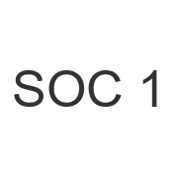

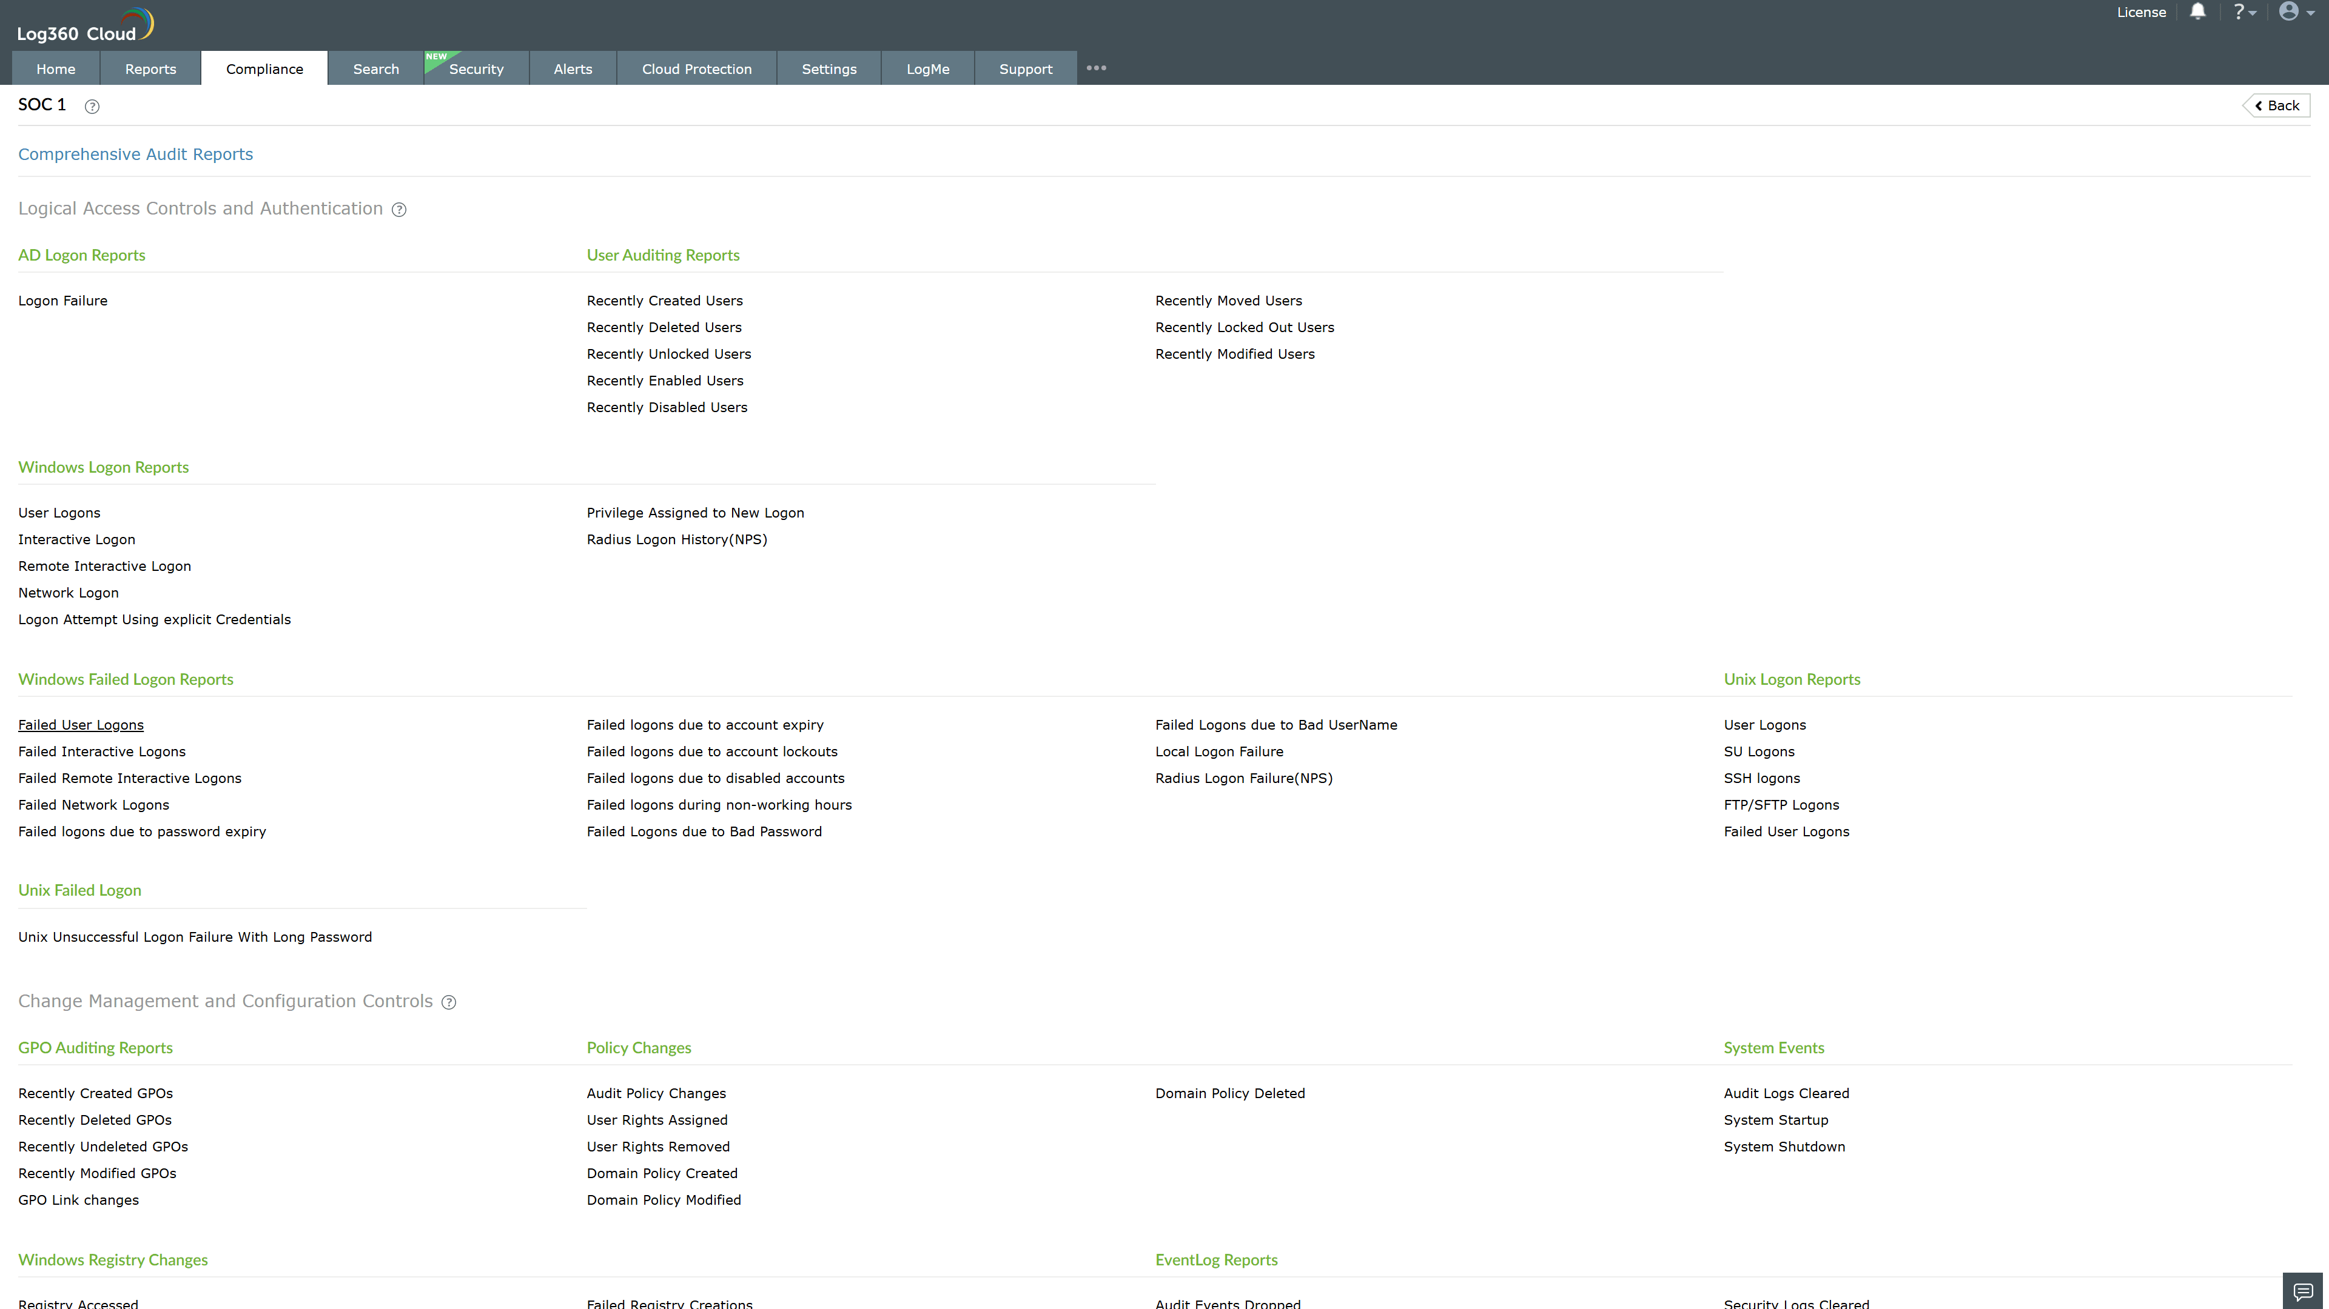
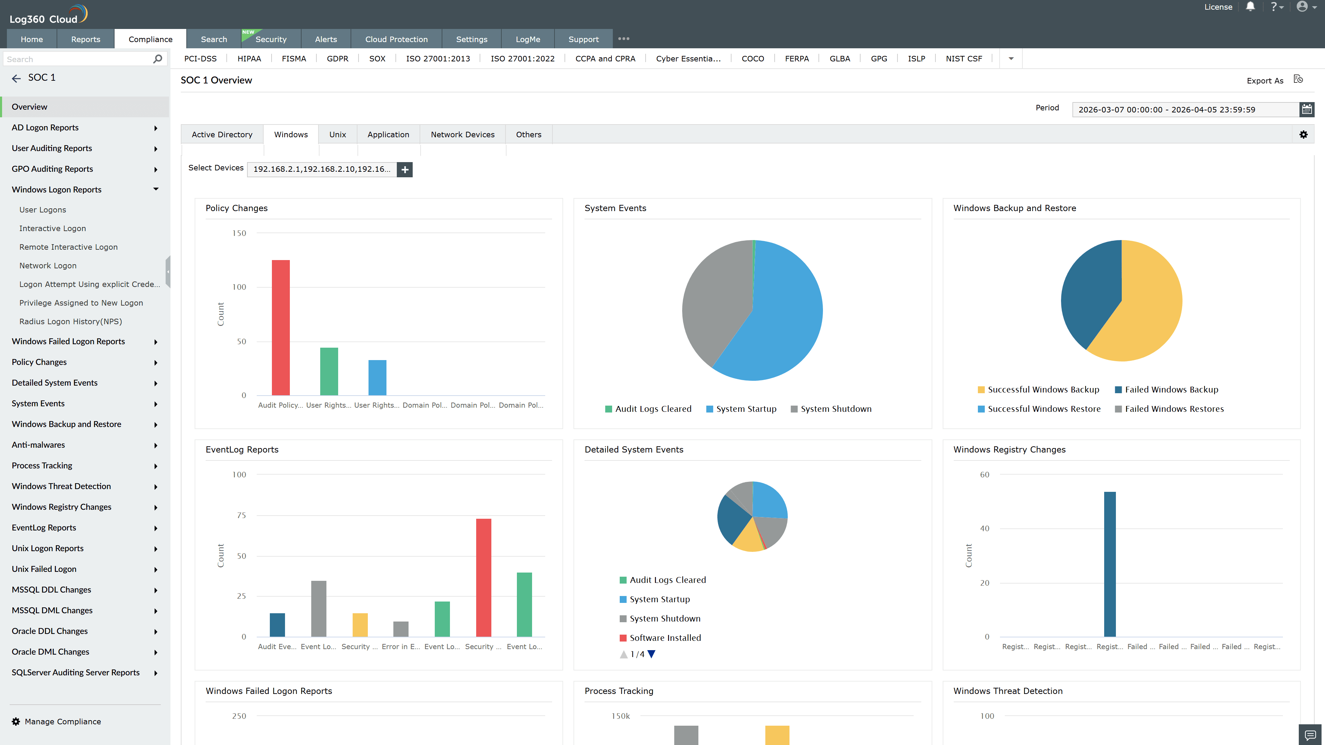
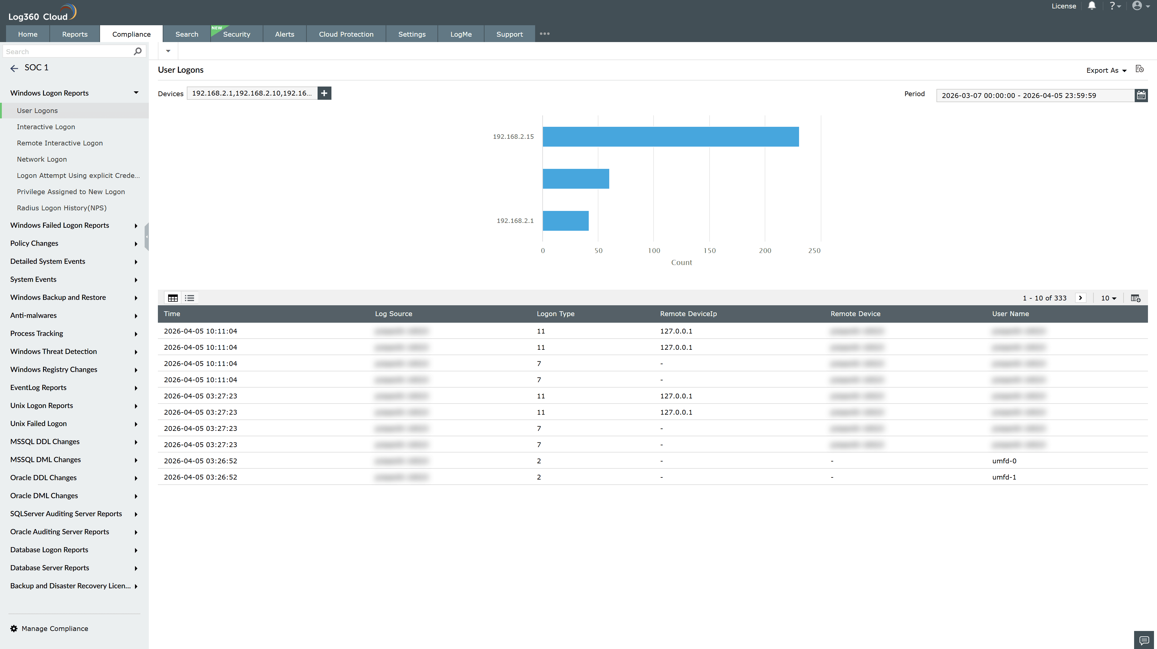
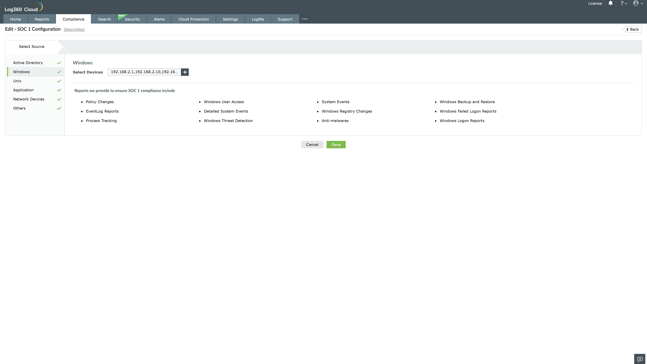
Valid Submission : Yes
Supported Editions : Free, Basic, Standard, Professional, MSSP
Help Document : https://www.manageengine.com/log-management/help/integrations/compliance-extensions.html
Help Video : Not provided
Tags : Log360, Compliance, Privacy monitoring, Data privacy, Regulatory compliance
Supported DCs : US, IN, JP, CA, AU, UK and EU
Privacy Policy:
Terms of Service:
Release Notes:
Predefined reports for the SOC 1.

